NAMA : ANISAH FAJRIAWATI

NPM : 1706979801

TUGAS 5 MENGISI INDOMARC

METADATA B

**Rekaman Video**

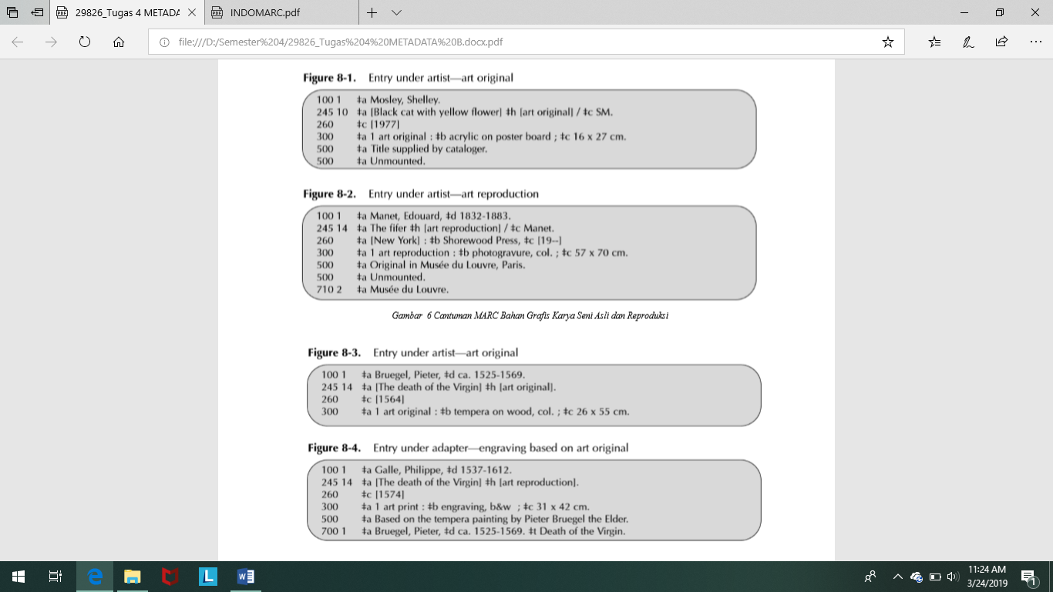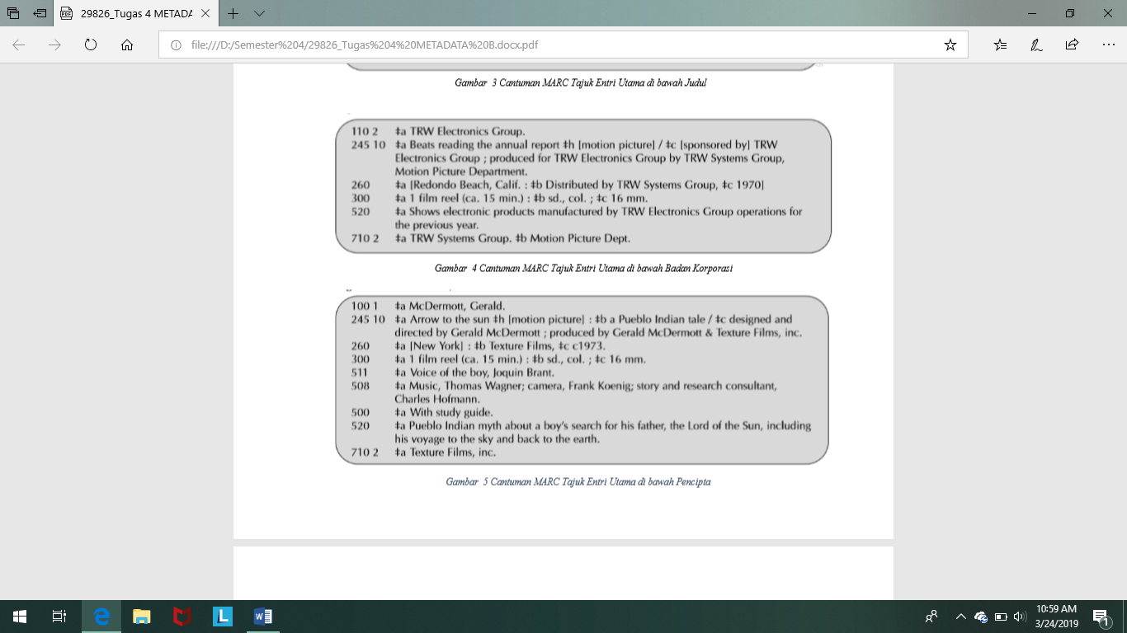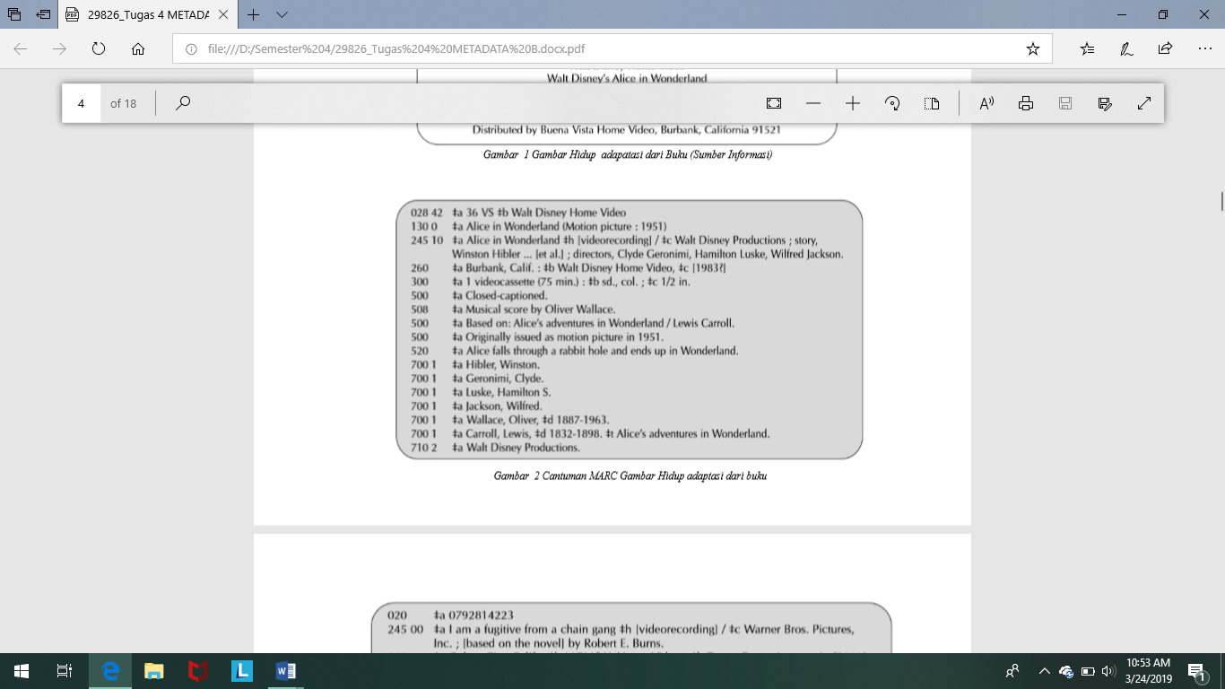

**Bahan Grafis**

**Citra Bergerak**

**LEMBAR KERJA :** **REKAMAN VIDEO**

|  |  |  |  |  |  |  |  |  |  |  |  |  |  |  |  |  |  |  |  |  |  |  |  |  |  |  |  |  |  |
| --- | --- | --- | --- | --- | --- | --- | --- | --- | --- | --- | --- | --- | --- | --- | --- | --- | --- | --- | --- | --- | --- | --- | --- | --- | --- | --- | --- | --- | --- |
| **Nomor kendali (001)** | | | | | | | |  |  |  |  |  |  |  |  | **BIB-ID (035) (salin dari komputer)** | | | | | | | | | | | | | |
|  |  |  |  |  |  |  |  |  |  |  |  |  |  |  |  |  |  |  |  |  |  |  |  |  |  |  |  |  |  |
|  |  |  |  |  |  |  |  |  |  |  |  |  |  |  |  |  |  |  |  |  |  |  | - |  |  |  |  | 6 | 0 |
|  |  |  |  |  |  |  |  | |  |  |  |  |  |  |  | |  |  |  |  |  |  |  |  |  |  |  |  |  |
| **006 Karakteristik Bahan Sertaan – Keterangan Umum** | | | | | | | | | | | | | | | | | | | | | | |  |  |  |  |  |  |  |
|  |  |  |  |  |  | |  |  | |  |  |  |  |  |  |  |  |  | |  | |  |  |  |  |  |  |  |  |
| Bentuk bahan pustaka |  | Lama waktu tayang |  |  | Belum ditetapkan | |  | Kelompok sasaran | | Belum ditetapkan |  |  | Terbitan pemerintah |  | Bentuk bahan |  |  | Belum ditetapkan | | Jenis bahan pustaka visual | |  | Teknik |  |  |  |  |  |  |
|  |  |  |  |  |  |  |  |  |  |  |  |  |  |  |  |  |  |  |  |  |  |  |  |  |  |  |  |  |  |
|  |  |  |  |  |  |  |  |  |  |  |  |  |  |  |  |  |  |  |  |  |  |  |  |  |  |  |  |  |  |
| k |  | 075 |  |  |  |  |  | g |  |  |  |  |  |  | s |  |  |  |  | v |  |  | a |  |  |  |  |  |  |

**007 – Ruas kendali**

|  |  |  |  |  |  |  |  |  |
| --- | --- | --- | --- | --- | --- | --- | --- | --- |
| Jenis bahan pustaka | Keterangan bahan khusus | Belum ditetapkan | Warna | Format rekaman video | Suara pada medium | Medium suara | Dimensi | Konfigurasi saluran alat putar |
|  |  |  |  |  |  |  |  |  |
|  |  |  |  |  |  |  |  |  |
| v | f |  | c | a | a | f | o |  |

**008 -- Data yang panjangnya tetap**

|  |  |  |  |  |  |  |  |  |  |  |  |  |  |  |  |  |  |  |  |  |  |  |
| --- | --- | --- | --- | --- | --- | --- | --- | --- | --- | --- | --- | --- | --- | --- | --- | --- | --- | --- | --- | --- | --- | --- |
| Tanggal pemasukan data(salindarikomputer) | Jenis tahun terbit | Tahun 1 | | | | Tahun 2 | | | | Tempat terbit, produksi danpelaksanaan | Lama waktu tayang | Belum ditetapkan | Kelompok sasaran | Belum ditetapkan | Terbitan pemerintah | Bentuk bahan | Belum ditetapkan | Jenis bahan pustaka visual | Teknik | Bahasa | Modifikasi cantuman | Sumber pengkatalogan |
|  |  |  |  |  |  |  |  |  |  |  |  |  |  |  |  |  |  |  |  |  |  |  |
| 2019/03/27 |  |  |  |  |  |  |  |  |  |  |  |  |  |  |  |  |  |  |  |  |  |  |
| 2019/03/27 |  | 1 | 9 | 8 | 3 | 1 | 9 | 8 | 3 |  |  |  | g |  |  | s |  | v | a |  |  |  |

|  |  |  |  |  |
| --- | --- | --- | --- | --- |
| **Nama ruas** | **Tag** | **Indikator** | | **Isi ruas** |
|  |  |  |  |  |
|  |  |  |  |  |
| No. ISBN | 020 |  |  |  |
|  |  |  |  |  |
| Tgl. / waktu dan tempat peristiwa | 033 |  |  |  |
|  |  |  |  |  |
| Sumber katalogisasi | 040 |  |  |  |
|  |  |  |  |  |
| Bahasa | 041 |  |  |  |
|  |  |  |  |  |
| Kode wilayah | 043 |  |  |  |
|  |  |  |  |  |
| No. panggil (DDC) | 082 |  |  |  |
|  |  |  |  |  |
| Nomor panggil (lokal) | 084 |  |  |  |
|  |  |  |  |  |
| Judul | 245 | 1 | 0 | $aAlice in Wonderland $h[rekaman video] / $cWalt Disney Productions ; cerita oleh Winston Hibler … [et al.] ; sutradara, Clyde Geronimi … [et al.] |
|  |  |  |  |  |
| Bentuk judul lain | 246 |  |  |  |
|  |  |  |  |  |
| Keterangan Publikasi | 260 |  |  | $aBurbank, Calif. : $bWalt Disney Home Video, $c[1983?] |
|  |  |  |  |  |
| Deskripsi fisik | 300 |  |  | $a1 kaset video (75 menit) : $bsd., col. ; $c1/2 in. |
|  |  |  |  |  |
| Catatan : |  |  |  |  |
| Umum |  |  |  |  |
| 500 |  |  | $aTeks tertutup. |
| Isi |  |  |  |  |
| 505 |  |  |  |
| Peranserta |  |  |  |  |
| 508 |  |  | $aSkor musik oleh Oliver Wallace. |
|  |  |  |  |  |
| Tgl. / waktu dan tempat peristiwa | 518 |  |  |  |
| Ringkasan isi, dsb. |  |  |  |  |
| 520 |  |  | $aAlice terjatuh ke dalam lubang kelinci dan berakhir di Wonderland. |
| Kelompok pembaca |  |  |  |  |
| 521 |  |  |  |
|  |  |  |  |  |
| Tajuk subyek |  |  |  |  |
| Nama orang |  |  |  |  |
| 600 |  |  |  |
| Nama badan korporasi |  |  |  |  |
| 610 |  |  |  |
| Nama pertemuan |  |  |  |  |
| 611 |  |  |  |
| Topik |  |  |  |  |
| 650 |  |  |  |
| Wilayah |  |  |  |  |
| 651 |  |  |  |
|  |  |  |  |  |
| Tajuk tambahan : |  |  |  |  |
| Nama orang |  |  |  |  |
| 700 | 1 |  | $aHibler, Winston. |
| Nama badan korporasi |  |  |  |  |
| 710 | 2 |  | $aWalt Disney Productions. |
| Judul seragam |  |  |  |  |
| 730 |  |  |  |
|  |  |  |  |  |
| Badan yang memiliki | 850 |  |  |  |
|  |  |  |  |  |
| Nomor | 984 |  |  |  |
|  |  |  |  |  |
|  | 500 |  |  | $aBerdasarkan: Alice’s adventures in Wonderland / Lewis Carroll. |
|  | 500 |  |  | $aAwalnya diterbitkan sebagai citra bergerak pada 1951. |
|  | 700 | 1 |  | $aGeronimi, Clyde. |
|  | 700 | 1 |  | $aLuske, Hamilton S. |
|  | 700 | 1 |  | $aJackson, Wilfred. |
|  | 700 | 1 |  | $aWallace, Oliver, $d1887-1963. |
|  | 700 | 1 |  | $aCarroll, Lewis, $d1832-1898. $tAlice’s adventures in Wonderland. |

**LEMBAR KERJA : CITRA BERGERAK (MOTION PICTURE)**

|  |  |  |  |  |  |  |  |  |  |  |  |  |  |  |  |  |  |  |  |  |  |  |  |  |  |  |  |  |  |
| --- | --- | --- | --- | --- | --- | --- | --- | --- | --- | --- | --- | --- | --- | --- | --- | --- | --- | --- | --- | --- | --- | --- | --- | --- | --- | --- | --- | --- | --- |
| **Nomor kendali (001)** | | | | | | | |  |  |  |  |  |  |  | **BIB-ID (035) (salin dari komputer)** | | | | | | | | | | | | |  |  |
|  |  |  |  |  |  |  |  |  |  |  |  |  |  |  |  |  |  |  |  |  |  |  |  |  |  |  |  |  |  |
|  |  |  |  |  |  |  |  |  |  |  |  |  |  |  |  |  |  |  |  |  |  | - |  |  |  |  |  | 6 | 0 |
| **006 Karakteristik Bahan Sertaan – Keterangan Umum** | | | | | | | | | | | | | | | | | | | | | |  |  |  |  |  |  |  |  |
|  |  |  |  |  |  | |  |  | |  |  |  |  |  |  |  |  | |  | |  |  | |  | | | |  |  |
| Bentuk bahan pustaka |  | Lama waktu tayang |  |  | Belum ditetapkan | |  | Kelompok sasaran | | Belum ditetapkan |  |  | Terbitan pemerintah |  | Bentuk bahan |  | Belum ditetapkan | | Jenis bahan pustaka visual | |  | Teknik | |  | | | |  |  |
|  |  |  |  |  |  |  |  |  |  |  |  |  |  |  |  |  |  |  |  |  |  |  |  |  |  |  |  |  |  |
|  |  |  |  |  |  |  |  |  |  |  |  |  |  |  |  |  |  |  |  |  |  |  |  |  |  |  |  |  |  |
| g |  | 015 |  |  |  |  |  |  |  |  |  |  |  |  |  |  |  |  | m |  |  | a |  |  |  |  |  |  |  |

**007 – Ruas kendali**

|  |  |  |  |  |  |  |  |  |  |  |  |  |  |  |  |  |  |  |
| --- | --- | --- | --- | --- | --- | --- | --- | --- | --- | --- | --- | --- | --- | --- | --- | --- | --- | --- |
| Jenis bahan pustaka | Keterangan bahan khusus | Belum ditetapkan | Warna | Format penyajian citrabergerak | Suara dalam medium | Medium suara | Dimensi | Konfigurasi | Unsur produksi | Aspek positif negatif | Generasi | Dasar film | Kategori warna | Jenis color stock dan cetakan | Tingkat kehancuran | Tingkat kelengkapan | Tanggal pemeriksaan film |  |
|  |  |  |  |  |  |  |  |  |  |  |  |  |  |  |  |  |  |  |
|  |  |  |  |  |  |  |  |  |  |  |  |  |  |  |  |  |  |  |
| M | r |  | u | u | u | u | d | u | z | u | u | u | u | u |  |  |  |  |

**008 – Unsur data yang panjangnya tetap**

|  |  |  |  |  |  |  |  |  |  |  |  |  |  |  |  |  |  |  |  |  |  |  |
| --- | --- | --- | --- | --- | --- | --- | --- | --- | --- | --- | --- | --- | --- | --- | --- | --- | --- | --- | --- | --- | --- | --- |
| Tanggal pemasukan data(salindarikomputer) | Jenis tahun terbit | Tahun 1 | | | | Tahun 2 | | | | Tempat terbit, produksi danpelaksanaan | Lama waktu tayang | Belum ditetapkan | Kelompok sasaran | Belum ditetapkan | Terbitan pemerintah | Bentuk bahan | Belum ditetapkan | Jenis bahan pustaka visual | Teknik | Bahasa | Modifikasi cantuman | Sumber pengkatalogan |
|  |  |  |  |  |  |  |  |  |  |  |  |  |  |  |  |  |  |  |  |  |  |  |
| 2019/03/27 |  |  |  |  |  |  |  |  |  |  |  |  |  |  |  |  |  |  |  |  |  |  |
| 2019/03/27 |  | 1 | 9 | 7 | 3 | 1 | 9 | 7 | 3 |  | 015 |  |  |  |  | s |  | m | a |  |  |  |

|  |  |  |  |  |  |
| --- | --- | --- | --- | --- | --- |
| **Nama ruas** |  | **Tag** | **Indikator** | | **Isi ruas** |
|  |  |  |  |  |  |
| No. hak cipta | atau |  |  |  |  |
| deposit |  | 017 |  |  |  |
|  |  |  |  |  |  |
| Sumber katalogisasi |  | 040 |  |  |  |
|  |  |  |  |  |  |
| No. panggil (DDC) |  | 082 |  |  |  |
|  |  |  |  |  |  |

|  |  |  |  |  |  |  |
| --- | --- | --- | --- | --- | --- | --- |
| Nomor panggil (lokal) | | | 084 |  |  |  |
|  |  |  |  |  |  |  |
| Judul |  |  | 245 | 1 | 0 | $aArrow to the sun $h[citra bergerak] :$ba Pueblo Indian tale / $csutradara dan desain oleh Gerald McDermott ; produser oleh Gerald McDermott and Texture Films, inc. |
|  |  |  |  |  |  |  |
| Negara | tempat | produksi |  |  |  |  |
| film arsip | |  | 257 |  |  |  |
|  | | |  |  |  |  |
| Keterangan Publikasi | | | 260 |  |  | $aNew York : $bTexture Films, $cc1973. |
|  | |  |  |  |  |  |
| Deskripsi fisik | |  | 300 |  |  | $a1 gulungan filem (ca. 15 min.) : $bsd., col.; $c16 mm. |
|  | |  |  |  |  |  |
| Catatan : | |  |  |  |  |  |
|  | |  |  |  |  |  |
| Umum | |  | 500 |  |  | $aDengan Panduan Belajar. |
| Peranserta | |  | 508 |  |  |  |
|  |  |  | $aMusik, Thomas Wagner ; camera, Frank Koenig ; story and research consultant, Charles Hofmann. |
| Kutipan / rujukan | | | 510 |  |  |  |
|  |  |  |
| Peserta / pelaku | | | 511 |  |  |  |
|  |  | $aSuara laki-laki, Joquin Brant. |
| Ringkasan isi, dsb. | | | 520 |  |  |  |
|  |  | $aMitos Pueblo Indian tentang seorang laki-laki mencari ayahnya, The Lord of The Sun, termasuk pelayarannya ke langit dan kembali ke Bumi. |
| Penggunaan dan | | |  |  |  |  |
|  |  |  |  |
| reproduksi | | | 540 |  |  |  |
| Tajuk subyek | |  |  |  |  |  |
|  |  |  |  |  |
|  | |  |  |  |  |  |
| Nama orang | |  | 600 |  |  |  |
| Topik |  |  | 650 |  |  |  |
|  |  |  |  |  |
|  | |  |  |  |  |  |
| Tajuk tambahan | |  |  |  |  |  |
| Nama orang | |  | 700 |  |  |  |
|  |  |  |  |
| Badan korporasi | | | 710 |  |  |  |
| 2 |  | $aTexture Films, inc. |
|  | |  |  |  |  |  |
| Entri induk | |  | 773 |  |  |  |
|  |  |  |  |  |  |  |
|  |  |  | 776 |  |  |  |
|  | |  |  |  |  |  |
| Entri pendahulu | |  | 780 |  |  |  |
|  | | |  |  |  |  |
| Badan yang memiliki | | | 850 |  |  |  |
|  |  |  |  |  |  |  |
| Lokasi | dan | akses | 856 |  |  |  |
| elektronik | |  |  |  |  |  |
|  |  |  |  |  |  |  |
| Nomor |  |  | 984 |  |  |  |
|  |  |  |  |  |  |  |
|  |  |  |  |  |  |  |

**LEMBAR KERJA : LUKISAN / GAMBAR / FOTO TERCETAK, DSB.**

|  |  |  |  |  |  |  |  |  |  |  |  |  |  |  |  |  |  |  |  |  |  |  |  |  |  |  |  |  |  |
| --- | --- | --- | --- | --- | --- | --- | --- | --- | --- | --- | --- | --- | --- | --- | --- | --- | --- | --- | --- | --- | --- | --- | --- | --- | --- | --- | --- | --- | --- |
| **Nomor kendali (001)** | | | | | | | |  |  |  |  |  |  |  |  | **BIB-ID (035) (salin dari komputer)** | | | | | | | | | | | | | |
|  |  |  |  |  |  |  |  |  |  |  |  |  |  |  |  |  |  |  |  |  |  |  |  |  |  |  |  |  |  |
|  |  |  |  |  |  |  |  |  |  |  |  |  |  |  |  |  |  |  |  |  |  |  | - |  |  |  |  | 6 | 0 |
| **006 Karakteristik Bahan Sertaan – Keterangan Umum** | | | | | | | | | | | | | | | | | | | | | | |  |  |  |  |  |  |  |
|  |  |  |  |  |  | |  |  | |  |  |  |  |  |  |  |  |  | |  | |  |  |  |  |  |  |  |  |
| Bentuk bahan pustaka |  | Lama waktu tayang |  |  | Belum ditetapkan | |  | Kelompok sasaran | | Belum ditetapkan |  |  | Terbitan pemerintah |  | Bentuk bahan |  |  | Belum ditetapkan | | Jenis bahan pustaka visual | |  | Teknik |  |  |  |  |  |  |
|  |  |  |  |  |  |  |  |  |  |  |  |  |  |  |  |  |  |  |  |  |  |  |  |  |  |  |  |  |  |
|  |  |  |  |  |  |  |  |  |  |  |  |  |  |  |  |  |  |  |  |  |  |  |  |  |  |  |  |  |  |
| k |  |  |  |  |  |  |  |  | g |  |  |  |  |  | r |  |  |  |  | c |  |  | z |  |  |  |  |  |  |

**007 – Ruas kendali**

|  |  |  |  |  |  |
| --- | --- | --- | --- | --- | --- |
| Jenis bahan pustaka | Keterangan bahan khusus | Belum ditetapkan | Warna | Bahan dasar utama | Bahan dasar pendukung |
|  |  |  |  |  |  |
|  |  |  |  |  |  |
| a | e |  | c | A |  |

**008 – Unsur data yang panjangnya tetap**

|  |  |  |  |  |  |  |  |  |  |  |  |  |  |  |  |  |  |  |  |  |  |  |
| --- | --- | --- | --- | --- | --- | --- | --- | --- | --- | --- | --- | --- | --- | --- | --- | --- | --- | --- | --- | --- | --- | --- |
| Tanggal pemasukan data(salindarikomputer) | Jenis tahun terbit | Tahun 1 | | | | Tahun 2 | |  |  | Tempat terbit, produksi danpelaksanaan | Lama waktu tayang | Belum ditetapkan | Kelompok sasaran | Belum ditetapkan | Terbitan pemerintah | Bentuk bahan | Belum ditetapkan | Jenis bahan pustaka visual | Teknik | Bahasa | Modifikasi cantuman | Sumber pengkatalogan |
|  |  |  |  |  |  |  |  |  |  |  |  |  |  |  |  |  |  |  |  |  |  |  |
| 2019/03/27 |  |  |  |  |  |  |  |  |  |  |  |  |  |  |  |  |  |  |  |  |  |  |
| 2019/03/27 |  | 1 | 9 | - | - | 1 | 9 | - | - |  |  |  | g |  |  | r |  | i | z |  |  |  |

|  |  |  |  |  |
| --- | --- | --- | --- | --- |
| **Nama ruas** | **Tag** | **Indikator** | | **Isi ruas** |
|  |  |  |  |  |
|  | 019 |  |  |  |
|  |  |  |  |  |
| Sumber pengkatalogan | 040 |  |  |  |
|  |  |  |  |  |
| Tajuk utama : |  |  |  |  |
|  |  |  |  |  |
| Nama orang | 100 | 1 |  | $aManet, Edouard, $d1832-1883. |
|  |  |  |  |  |
| Judul | 245 | 1 | 4 | $aThe fifer $h[karya reproduksi] / $cManet. |
|  |  |  |  |  |
| Penerbitan, distribusi, dsb. | 260 |  |  | $aNew York : $bShorewood Press, $c19-- |
|  |  |  |  |  |
| Deskripsi fisik | 300 |  |  | $a1 karya reproduksi : $blukisan, col.; $c57 x 70 cm. |
|  |  |  |  |  |
| Catatan : |  |  |  |  |
|  |  |  |  |  |
| Umum | 500 |  |  | $aKarya asli di Museum Louvre, Paris. |
|  |  |  |  |  |
| Reproduksi | 533 |  |  |  |
|  |  |  |  |  |
| Tajuk subyek : |  |  |  |  |
|  |  |  |  |  |
| Nama orang | 600 |  |  |  |
|  |  |  |  |  |
| Nama badan korporasi | 610 |  |  |  |
|  |  |  |  |  |
| Topik | 650 |  |  |  |
|  |  |  |  |  |
| Entri induk | 773 |  |  |  |
|  |  |  |  |  |
| Entri tambahan seri : |  |  |  |  |
|  |  |  |  |  |
| Judul seragam | 830 |  |  |  |
|  |  |  |  |  |
| Badan yang memiliki | 850 |  |  |  |
|  |  |  |  |  |
| Lokasi dan akses elektronik | 856 |  |  |  |
|  |  |  |  |  |
| Nomor | 984 |  |  |  |
|  |  |  |  |  |
|  | 500 |  |  | $aTak berbingkai. |
|  |  |  |  |  |
|  |  |  |  |  |
|  |  |  |  |  |
|  |  |  |  |  |

Sumber rujukan:

Maxwell, R. L. (2004). Maxwell's Handbook for AACR2: explaining and illustrating the angloamerican cataloguing rules throught the 2003 update. Chicago: American Library Association.